THE ANGLE SOCIETY OF EUROPE

Requirements
for Case Presentation Edition 2022

Appendix I to the Bylaws.

The ASE Example Case Report.

It is within the spirit of these requirements that all the cases presented for the membership have been treated by and under the full responsibility of the applicant, following post graduate qualification. Cases should be selected to demonstrate diagnostic judgment and treatment control, with a high standard of completion. Cases which do not provide an adequate basis for evaluation, judgment and ability are not acceptable. Difficulty of the malocclusion is given due consideration in evaluation.

Number of Cases

A total of 10 cases shall be presented as requested by the Scientific Committee: 5 cases for provisional membership and 5 additional cases for active membership.
Out of the 10 cases, 3 cases shall be at least one year out of retention (bonded retainers are acceptable if justified) with all permanent teeth erupted, with the exception of the third molars. When second molars have been extracted, the replacing third molars should be in occlusion.

The case display for Active membership in total shall include:

_One Class II division 1 non-extraction case
_One Class II or Class III extraction case
_One Class II division 2 case. This case should exhibit an anterior deep bite with at least two retroclined incisors and a Class II cuspid relationship.
At least one of the presented Class II cases should initially exhibit a severe skeletal discrepancy.
_One Class III case or a case with Class III tendency.
_One case started in the mixed dentition.
_One adult, non-growing case.
_Other cases as diversified as the practice permits.

Therefore, the selection of cases will take into consideration the cases presented for provisional membership.

Each case will be evaluated by the Scientific Committee and put into one of the three categories.
“Case Certified” is a case that meets the full standard for Active Membership.
“Case accepted” is accepted but needs to be revised or replaced.
“Case rejected” is not accepted.

When a member is accepted for Provisional Membership, he or she will be informed at the oral interview, or soon after what type of cases will be necessary in the display for Active Membership.

Records to be shown

Minimum records to be included in case reports are the following:

  - Before any active treatment (including extractions) = “A” records
- dental casts
- dental radiographs (periapical or panoramic)
- facial photographs (front and profile)
- intraoral photographs (at least frontal and lateral views)
- cephalometric records

  - At the conclusion of major active treatment = “B” records
- dental casts
- dental radiographs (not required if included in “C” records)
- facial photographs
- intraoral photographs
- cephalometric records (can be taken prior to removal of fixed appliance)

  - At least two years after completion of active treatment = “C” records
- dental casts
- dental radiographs (optional if included in the B records)
- facial photographs
- intraoral photographs
- cephalometric records (optional)

The minimum, mandatory requirements listed above are not intended to discourage the inclusion of additional pertinent records, such as dental photographs or other records made at different stages of treatment. Supplemental records made at other stages of treatment should be clearly labelled so that they are not confused with the above required records.
Cephalometric records at least two years after active treatment are optional, because it can be difficult to justify that these records are to the benefit for the patient. Cephalometric records and growth analysis at the end of growth are often the only way the treatment can be truly judged though. The applicant is therefore encouraged to bring these records and analysis, if they are available.

Exceptions
The Scientific Committee realizes that strict adherence to the above stipulations in every one of the case reports might necessitate the exclusion of a case which deserved to be a part of the exhibition. Photographs and radiographs may occasionally become lost or not be permitted by the patient or by regulations. Such an omission will be acceptable if it is explained in the case history and is not a vital part of the presentation. It is emphasized however that records generally must be complete for the cases shown, but case evaluation will be at the discretion of the Scientific Committee.

Case history

In addition to the clinical records listed above, each case report must include a written case history, prepared according to the outline shown in The ASE Example Case Report.

Supplementary information of records to be included in case reports:

Radiographs
In recognition of good radiation hygiene practices, the Scientific Committee emphasizes that it does not wish to imply that radiographs should be taken solely to satisfy case requirements for presentation. The cephalometric radiograph at the end of active treatment can for diagnostic purposes be taken prior to removal of the fixed appliance.

Dental radiographs
should be mounted with right and left sides clearly marked on both sides of the mount.

Cephalometric radiographs
should be easily removable for viewing.

Cephalometric tracings
should face to the right. Computer tracings are acceptable with total anatomical lines constructed and equal size of the radiograph. Copies on transparent material are necessary to control the reliability of the tracings.
Tracings should be provided for all lateral views with different colours:
- pretreatment black
- treatment progress blue
- post- or near end of treatment red
- retention or postretention green

Cephalometric evaluations
must include the ASE analysis. Additional assessments are acceptable if clearly explained. For superimpositions the procedure as demonstrated in The ASE Example Case Report is mandatory.
Superimposition of pre-treatment and post- or near end of treatment profile radiographs (B-6) and superimpositions of the mandible and the maxilla (B-7) are mandatory. All other superimpositions marked with an asterisk (*) are optional.

Photographs
must be in colour and in print form.

Dental casts
must show accurate anatomic detail and texture.

Identification
Each item, including casts, cephalometric films, cephalometric tracings, x-rays, mounts and photographs, must be marked with the following information:
- case number or patients name
- date on which the record was made
- patient’s age to the nearest month
- stage of treatment (indicated by letter and coloured signal dot )

- - pre-treatment records
A-B - treatment progress
- - post- treatment
B-C - after active treatment but less than 2 years after end of active treatment
- - retention or post-retention records, at least 2 years after end of active treatment

“A” and “B” records are mandatory, others are optional. Coloured signal dots should be used for easier identification.

Outline for ASE case presentation

Pages:
0-1 Resume of case

Pre-treatment records
  - history and general clinical picture A-2 facial photographs
  - intraoral photographs
  - intraoral radiographs or panoramic radiograph A-5 lateral cephalogram
  - tracing A (in solid black)
  - cephalometric morphological assessment I (ASE)
  - text on radiographs and dental casts, and cephalometric analysis A-9 aetiology, diagnosis, plan of treatment
A-10 progress of case

Post-treatment records
  - facial photographs
  - intraoral photographs
  - intraoral radiographs or panoramic radiograph (not required if included in C) B-4 lateral cephalogram
  - tracing B (in solid red)
  - drawing of general superimposition of A-5 and B-4
  - drawing of maxillary and mandibular superimpositions of A-5 and B-4 B-8 cephalometric morphological assessment II (ASE)
  - post- treatment results
  - post-treatment evaluation, retention

Retention or Postretention
  - facial photographs
  - intraoral photographs
  - intraoral radiographs/ panoramic radiographs (optional if included in the B-records)
C - lateral cephalogram (optional)
  - tracing C (solid green) (optional)
  - drawing of general superposition of B-4 and C-4 (optional)
  - drawing of maxillary and mandibular superpositions of B-4 and C-4 (optional)
  - cephalometric morphological assessment III (ASE) (optional) C-9 retention / postretention findings (mandatory)
C-10 retention/ postretention evaluation and prognosis (mandatory)

Explanation of case description

Layout pages are for guidance only, additional pages may be added if required ( e.g. A-1 cont`d )

0-1 Abbreviate years/months to e.g. 12⁶. State date as well as age.
Treatment plan: Short abbreviation of treatment plan, e.g: 4 premolar extraction, max. anchorage, intrusion of anterior teeth etc. Appliances: Edgewise, Begg, functional app, auxiliaries as headgear, lip bumper.

A-1 ad B: Description of morphology of the head and face in lateral and frontal Views, lip closure, lip length, smile line etc.

ad C: Brief description of the jaw muscles and TMJ´s, tongue and lip posture and activity, mode of breathing. Opening and closing movements, joint sounds, occlusion, CR-CO discrepancy.

ad D: State of oral mucosa, gingiva, periodontium, caries and major restorations, abrasion, discoloration of teeth etc.

  - Cephalometric morphological assessment I (ASE), placed opposite page A-8. Possible other analysis can be inserted on the back side.

  - ad A: Missing teeth, endodontic treatment, root lengths, bone levels and pathologies.

ad B: Description of the information derived from the cephalometric morphological assessment describing sagittal and vertical discrepancies as well as other morphologically relevant features.

  - ad B: Angle´s classification together with a more detailed diagnosis. Is the malocclusion of skeletal or dental origin etc.

ad C: Detailed description of the treatment plan with clearly stated treatment objectives. If the treatment plan includes several stages, the aims of these should be described in detail. The treatment planning alternatives should be discussed.

  - Description of progress of treatment as related to the described plan.

  - Cephalometric morphological assessment II (ASE), placed opposite B-9. On the other side possible personal analysis can be added.

  - ad E: Description of the information obtained from the post-treatment morphological assessment.

Ad F: Detailed description of
-general facial changes
-changes in the maxilla
-changes in the mandible
based on the cephalometric superimpositions B-6 and B-7.

  - ad A: Critical review of the treatment and growth induced changes compared with the treatment plan and its alternatives in retrospective light.

Ad B: Short description of the appliances used and the principle aims of the retention phase. A discussion of the post-treatment prognosis should be included.

  - Cephalometric morphological assessment III (ASE), placed opposite C-9. (Optional)

C-9 | ad A: | Description of the information obtained from the retention  / post-retention extraoral and intraoral photographs. (Mandatory)
 | ad B: | Description of the changes from the post-treatment models. (Mandatory)
 | ad C: | Functional analysis at the time of retention / post-retention (Mandatory)
 | ad D: | Description of the findings on the retention /post-retention intraoral or panoramic radiograph.  (Mandatory, if not included in the post-treatment records).

Ad E: Description of the information obtained from the retention / post-retention morphological assessment. (Optional)

ad F: Detailed description of
    - general facial changes
    - changes in the maxilla
    - changes in the mandible
based on the cephalometric superimpositions C-6 and C-7. (Optional).

C-10 ad Retention / post-retention :
Critical review and discussion of retention / post-retention changes. (Mandatory)

ad Prognosis:
Evaluation of the potential long - term changes of the retention / post-retention result. (Mandatory)

CEPHALOMETRIC MORPHOLOGICAL ASSESSMENT

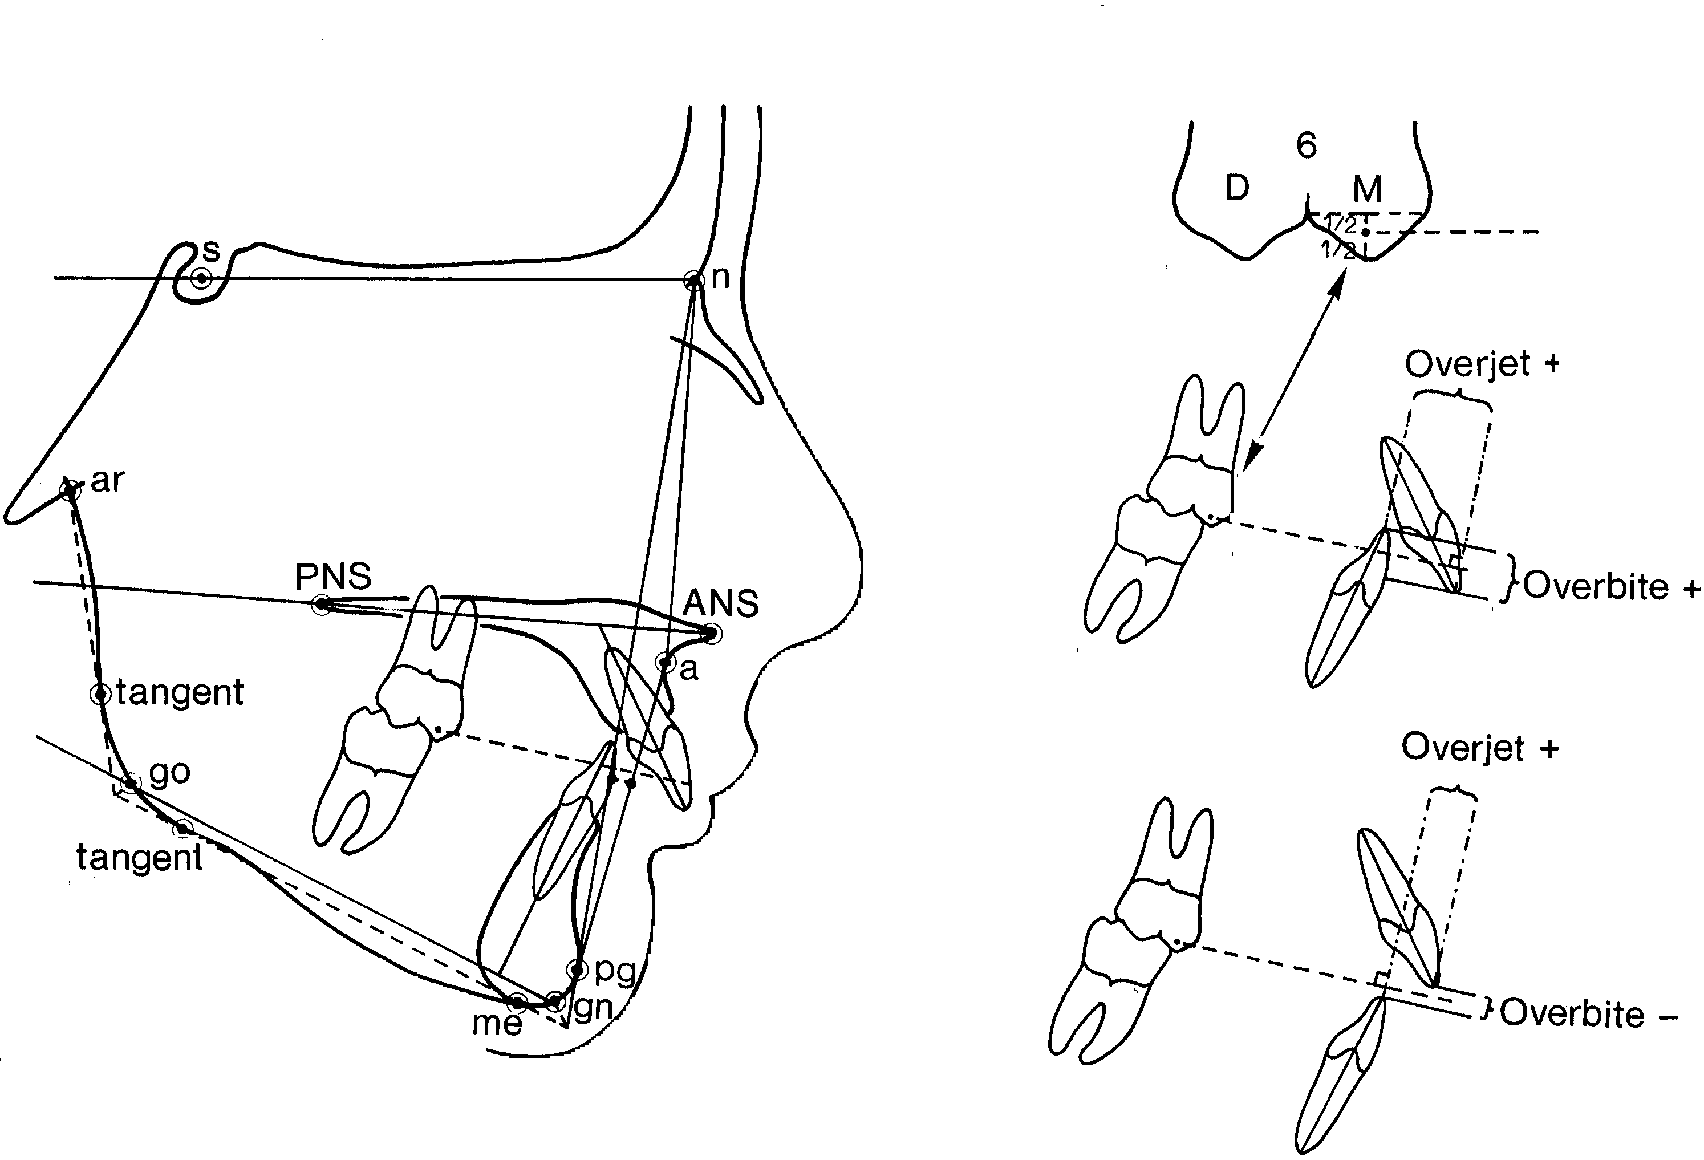

Digital records

The ASE digital format should be completed according to the bylaws (A-B-C records).

The case presentation should be displayed as a PDF file including 3D images of the casts (Danz and Katsaros AJODO 2011).
2D pictures of the casts should be included with appropriate perspectives.

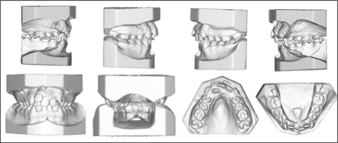

CBCT scans are accepted for diagnosis and treatment planning.

In cases treated with Clear Aligners the candidate should include the Digital Setup (ie. Initial Clincheck and refinements) used for the treatment. It is preferable to include intraoral pictures showing the coherence of the digital set up with the clinical progresses.

It is the responsibility of the Candidate / Member to justify its prescription and modalities of exposure considering the EU RX protection protocols.

Appropriate slices of a CBCT can replace an OPG and a lateral cephalogram although the latter is less useful for cephalometric analysis.

Superimpositions

Traditional superimpositions as currently requested will remain as the standard.

3D superimpositions will be accepted but displayed in a 2D format.

It is not acceptable to prescribe a further CBCT just for superimpositions.

The required cases of Guests and Provisional Members applying for Active Membership should be received by the SC 1 month before the annual meeting.

The digital case presentation should be sent on a digital support (Dropbox, WeTransfer, USB stick…).

The ASE might consider to collect these cases on a digital platform (ie. Business

Dropbox that complies with the EU GDPR).

The president of the SC will decide how to allocate the cases of the candidates to the judging members of the SC.

The SC has the right to ask information to the candidate about the case presentation prior to the meeting (via email, Zoom ….) to expedite the evaluation process.

All cases presented by ASE candidates and active members must include a form signed by the presenter, that images are not manipulated and that the cases were treated by the presenter.

